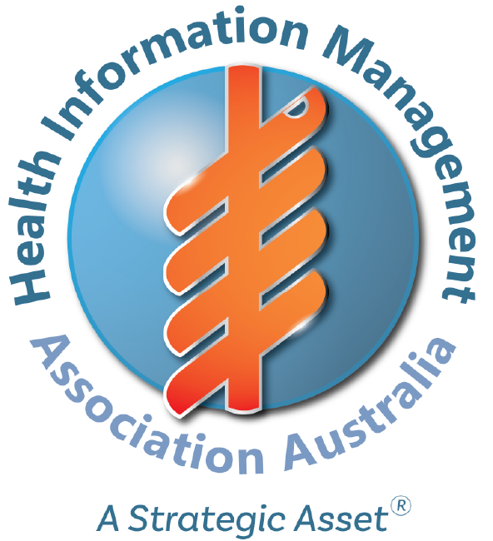

Health Information Management Association of Australia Pty Ltd

HIMAA GRANT REVIEW PANEL

Terms of Reference

Document Information

  - Version history [includes date of most recent TOR]*
    - Initial Draft Research Advisory Committee 20/10/2017
    - Final Draft Research Advisory Committee 21/02/2019
    - Approved by HIMAA Board as Version 1 on 01/06/2019
    - Revision Research Advisory Committee 27/11/2023
    - Approved by HIMAA Board as Version 1 on 12/12/2023

  - Sign off*
Endorsed by: Mary Lam Chair
HIMAA Research Advisory Committee
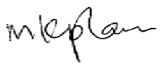
Date: 27/11/2023

Approved by: Catherine Garvey
HIMAA President
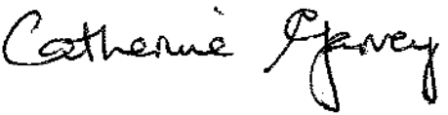
Date: 12/12/2023

Table of Contents

1) Purpose 4
2) Functions 4
3) Composition 4
4) Meetings 5
5) Accountability 7
6) Other 7

- Purpose
  - The Board of the Health Information Management Association of Australia (HIMAA) has established the Research Advisory Committee as part of its governance framework.
  - The Grant Review Panel is established in accordance with the HIMAA Research Grants Scheme Governance Framework.
  - This document establishes the authority and responsibility of the Grant Review Panel so that it may function effectively as part of the governance framework of the Association.
  - The Grant Review Panel is accountable to the HIMAA Board of Directors but for practical purposes will report to the Research Advisory Committee.
- Functions
  - The Grant Review Panel is responsible for the assessment of applications for funding under the HIMAA Research Grants Scheme and for making recommendations to the Research Advisory Committee.
- Composition
  - Chair
    - HIMAA Board-appointed Chair, who is a full member of HIMAA, with a recommendation made by the Research Advisory Committee, for a period of one to three (3) years, renewable.
    - The Chair is responsible for the Grant Review Panel executing their functions.

  - Membership
    - Is appointed by the HIMAA Board of Directors, in consultation with and following nomination by the Research Advisory Committee, for a period of one to three (3) years, renewable.
    - Comprises three (3) independent persons: two being qualified Health Information Managers and full members of HIMAA, one of whom is a member of the Research Advisory Committee, and a suitable external individual who demonstrates appropriate high level research knowledge and experience, and/or statistical or methodological expertise.
    - Where feasible, is representative geographically, that is no more than two (2) members of the Panel are from one state or territory.
    - Each member of the Grant Review Panel
- Has extensive experience in health information management practice, research practice and/or statistical methods and/or publication and/or membership of an institutional Human Research Ethics Committee and is familiar with HIMAA’s current research priorities (Research Priority List).
- Is excluded from submitting a research proposal, receiving a grant, or otherwise engaging in this program whilst he or she is a member of the Grant Review Panel.

  - Secretariat
    - Secretariat support will be provided by a HIMAA staff.
    - The Secretariat (in liaison with the Chair) will be responsible for the preparation and circulation of the meeting agenda (and supporting papers) and to take minutes.
    - The Secretariat will ensure that electronic copies of all relevant documents to the Committee (including agendas, position papers & minutes) are stored in central file that is backed up.

  - Induction of new members
    - As a form of induction, it is the responsibility of the Chair to provide new Members with a copy of the following prior to their first meeting:
    - The Terms of Reference (if not already supplied);
    - All associated grant application and review documentation.

- Meetings and Process
  - The Panel meets via email or teleconference as required, and the review and assessment process takes no longer than four (4) weeks.
  - A minimum of two (2) members of the Grant Review Panel evaluates and ranks each research proposal, including the Chair (or their delegate) and a second member of the Grant Review Panel (on a rotating basis).
  - Where a grant application includes, within the research team, any individual with a relationship to a member of the Grant Review Panel, that proposal is assessed and ranked by the other two Panel members and the affected member is not involved.
  - With the proposal or the decision. In this context, a significant relationship is taken to mean one of the categories listed in 6.2 below.
  - Where a member is unable to attend a meeting, the meeting should be rescheduled. Therefore, a quorum is 100% attendance.
  - Agenda
    - An agenda is to be prepared for meetings with relevant issues papers attached and distributed to members, at least 48 hours prior to the meetings.
    - Conflict of interests will be listed at the start of the meeting as a standing agenda item.
    - Agenda items may be considered out of session by electronic or other means and minutes should be provided at the next available meeting.
  - Minutes
    - Minutes of the meeting will be forwarded to members within 2 weeks following the meeting.
    - The Minutes must record the following:
    - Date of meeting
    - Attendees, apologies and absentees
    - Conflicts of interest
    - Agenda items discussed
    - Action items (including responsibility and timeframe)
    - Decisions taken (including rationale for decisions)
    - The Minutes must be approved by the Chair.
    - Once approved by the Chair, the Minutes of the meeting will be emailed to all members.
    - At each subsequent meeting, the minutes of the preceding meeting must be confirmed, including a review of the action items outstanding.

- Accountability
  - At the completion of each grant scheme review process, a report will be provided to the Research Advisory Committee in accordance with the HIMAA Research Grants Scheme Governance Framework.

- Conflict of Interest
  - To meet the ethical obligations under the Public Sector Ethics Act 1994, members must declare any actual, potential, or perceived conflicts of interest and manage those in consultation with the Chair.
  - When assessing submitted proposals, any member who has a connection to the proposal (including as author or via any relationship that may ordinarily be considered to present potential conflict of interest) recuses himself or herself from the discussion. In these circumstances the member will leave the meeting (hanging up the telephone in the case of a teleconference) until contacted by the Chair to re-join. In this context, a significant relationship is taken to mean:
    - A person from the same workplace as the Grant Review Panel member, or
    - A student, lecturer, or placement supervisor of the Grant Review Panel member, or
    - A relative or partner (business or personal) of the Grant Review Panel member, or
    - Any other close relationship that would normally constitute a potential conflict of interest.

- Confidentiality
  - Members may receive information regarded as ‘In-Confidence’, clinically confidential or have privacy implications.
  - It is a requirement that a deed of confidentiality is to be signed by all members of the Committee before participating in any Committee activity.

